**LAB 12 - (List)**

**Q1. Write a Python program to sum all the items in a list.**

**Sol:**

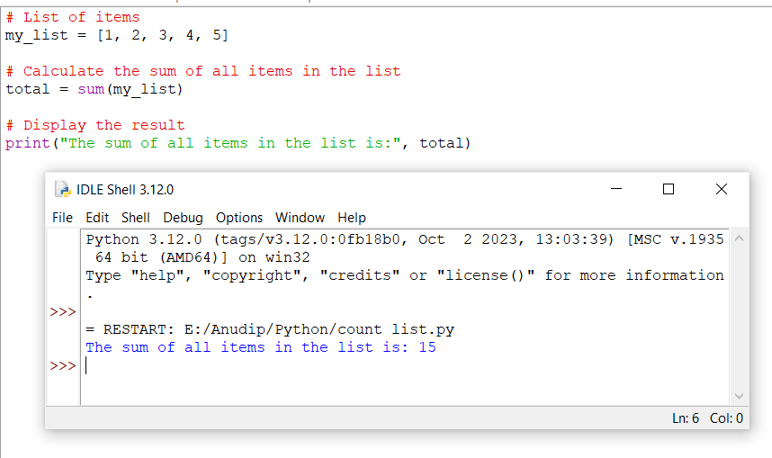

**Q2.Write a Python program to get the largest and smallest number from a list without builtin functions.**

**Sol:**

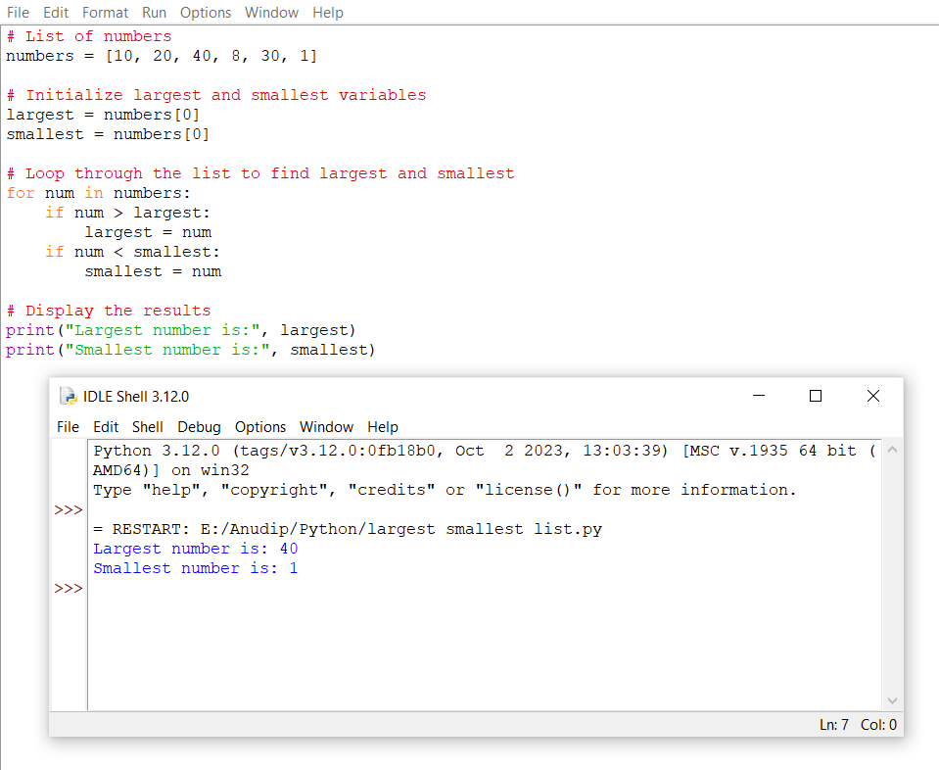

**Q3.Write a Python program to find duplicate values from a list and display those.**

**Sol:**

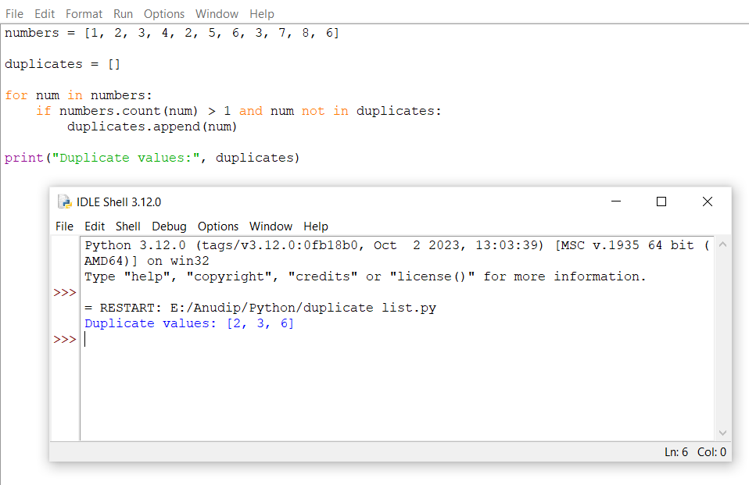

**Q4.Write a Python program to split a given list into two parts where the length of the first part of the list is given.**

**Original list: [1, 1, 2, 3, 4, 4, 5, 1]**

**Sol:**

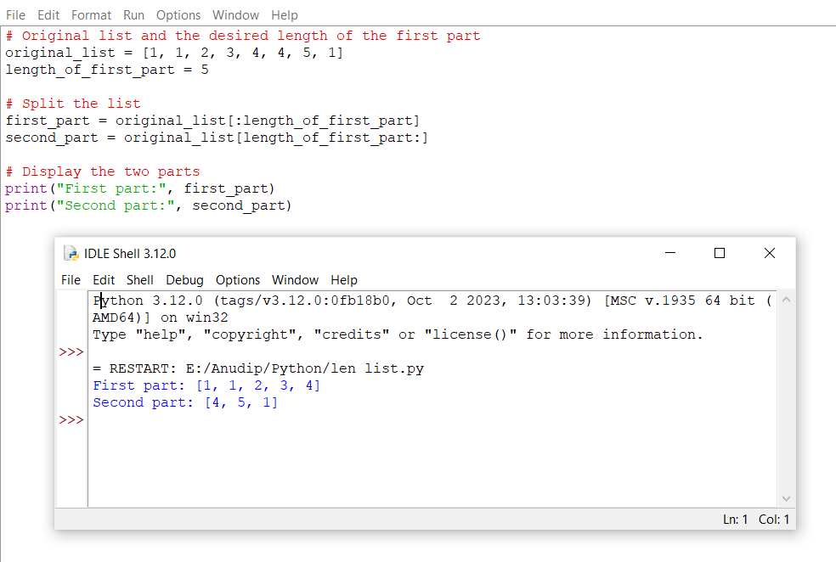

**Q5.Write a Python program to traverse a given list in reverse order, and print the**

**the elements with the original index. Original list: ['red', 'green', 'white', 'black']**

**Sol:**

